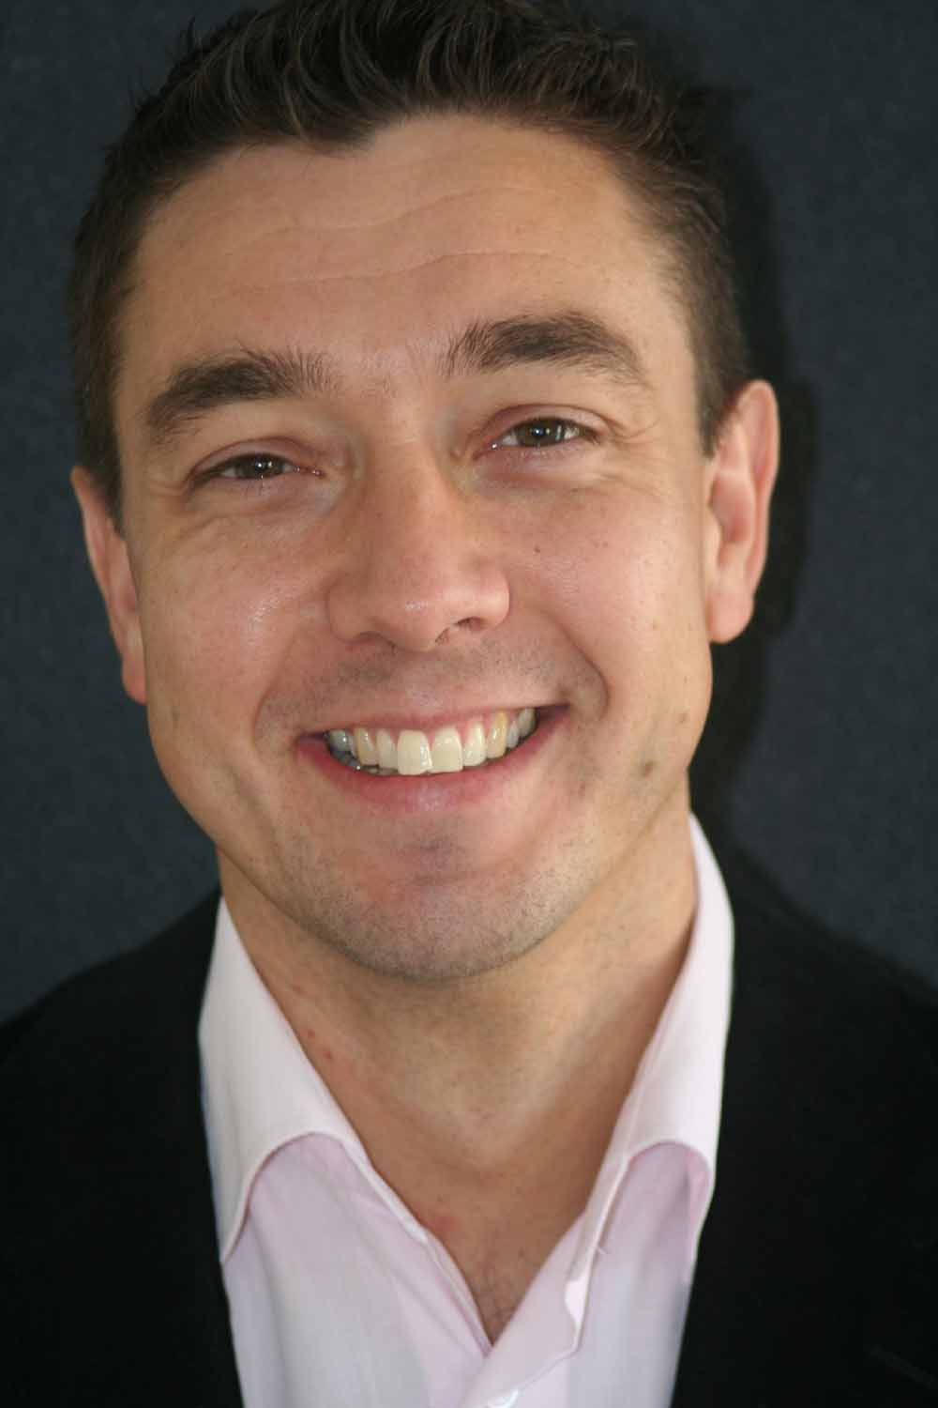
Marco Buschman, CPCC

Buschman Training & Coaching
Slotgracht 23, 5346 KG Oss
+31 6 46716141

info@stappenvoorwaarts.nl
www.stappenvoorwaarts.nl

Marco Buschman (1967) is an involved trainer & coach with a direct approach. He has extensive expertise in the field of line and change management, while leading teams and projects within non-profit and commercial organizations. As a manager he worked with a broad range of different people, companies and environments creating great results by connecting people emotionally to a shared stake. While doing so, he more and more developed his passion to coach people on their personal development. He helped them to find their core as a human being, be more effective in their (leadership) work and radiate that with power.

Trainer & coach
To fully integrate this passion in his work, in 2005 Marco gave up the management positions and started to work as a trainer & coach. Being employed by a large Dutch training institute he delivered trainings within the Netherlands and France. Besides this job he created his own company, focusing on leadership, training, (team)coaching, change and interim management. In 2007 he left the training institute to work 100% as an independent trainer & coach.

His attitude
Some characteristics that describe Marco’s style of work are his refreshing perspectives, sense of humor, originality and creative spirit, openness and most of all his interest in what truly occupies people’s minds. By means of value-free questions he invites individuals and teams to look from a different perspective to their well-known reality leading to more awareness and inner motivation. These are the basis for new insights and effective leadership behavior.

Customers
Some of the customers Marco worked for: KPN, Capgemini, ABN AMRO Bank, Rabobank, Electrabel, Achmea, BDO, Dutch Tax Office, Schouten & Nelissen, Royal Dutch Navy, GGZ Oost Brabant, Getronics and DSM.

Background study
Royal Military Academy, Military Business Administration
University of Nijmegen, Business Administration
Many soft skill, coaching & management trainings

Background companies
2006 – present: Buschman Training & Coaching - Trainer & Coach
2006 – 2007: Capgemini Academy - (international) trainer & coach
2004 – 2005: Capgemini - Manager Educational Services
2001 – 2004: Capgemini - Manager Powerbuilder/Sybase/Oracle/JAVA
1999 – 2001: Capgemini - Consultant/interim management
1997 – 1999: Royal Air Force – Manager Business Transformation
1995 – 1996: Royal Air Force – Manager Total Quality Management
1994 – 1994: Royal Air Force – Member taskforce reorganization
1990 – 1993: Royal Air Force – Air Defence Controller

